# Finishing your Story using “Fan In” of ScriptEase II

In this tutorial will be finishing our story. We will end the module only when both quests are finished by using a ScriptEase II feature called Fan In.

## Getting Started:

1. Back up your game files.
2. Make sure ScriptEase II is closed and open the module in Aurora. This will be the last time you open this module in Aurora.
3. Add another conversation node to the Root of captain_convo with the text “Are ye ready to go?” Have the player respond with “Aye aye, Capt’n!” and the Captain reply with “Alright me hearties! Raise the sails! We be leavin’ this island fer good.”
4. Save your module, close it, and open your story in ScriptEase II.

## Connecting Story Points and Using Fan In:

1. Add one more Story Point with the name “Game Finished” to the final Story Point in the main quest line (Figure 1).



Figure

1. We currently have two branching paths of Story Points that both have end points. Although this works fine, we do not want the pirates to leave before all of them are back on the ship. So let’s connect the last Story Point in the side quest to the last Story Point in the main quest.
2.  Story Point connection is done using the “Connect Story Points” tool. Use the connection tool by **dragging** from one Story Point to another. Connect the last Story Point in the side quest “Parrot Reunited” to the “Game Finished” Story Point. If the Game Finished point is outside of the screen, drag to the edge of the screen to automatically scroll.

Tip:The Story Point connection tool will only allow valid connections such that the story graph is not a cycle.

Tip:There is also a disconnect tool beside this one. Story Points without any connections will be removed.

Tip:You can add nodes between two story points by dragging between two nodes with the add node tool.

1. The Game Finished Story Point now has two Story Points connected to it. You have probably noticed the small “1” with two arrows inside of Story Points before. This is the “Fan In” control. Change the Fan In of Game Finished to 2 (Figure 2).

Tip: **Fan In** refers to the number of preceding Story Points that must be completed before the Story Point is activated. Since Game Finished’s fan in is now 2, we need to find the treasure, and reunite the parrot and pirate to reach the Story Point. If Fan In were 1, completing either one of those Story Points would activate Game Finished.



Figure

1. Add a “When story point is activated” cause to the Game Finished Story Point. Drag in the story point Game Finished to the slot.
2. In the Story Point “Current Active” Yes section, add a Journal Point to the Treasure Island Journal Record that says “I have finished everything. It’s time to talk to the Captain and leave.”
3. Add a “When subject is reached” cause to the Game Finished Story Point. Drag the “Alright me hearties! Raise the sails! We be leavin’ this island fer good.” dialogue line into the subject.
4. In the “Current Active” Yes section, add the “End the module with movie End Movie after Delay Time seconds” effect.

Tip:If we had a cutscene in bik format in the movies folder, we could make it play now by writing its file name into the text field. However, since we do not have one, we can just leave it blank.

1. Your Story Point should look like the following (Figure 3).

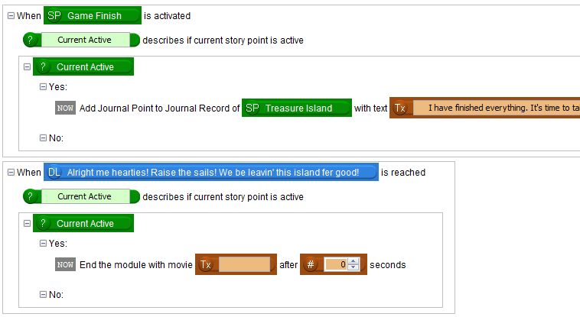

Figure

1. Save and test your story again. If this were a major project, you should now test it a few hundred more times and then get other people to test your story to find bugs and exploits.

That’s it! You have successfully finished the tutorials and created your own game loosely based off of Treasure Island.

If you want, you can go back and make your world more interesting by adding more pirates, more side quests, and more interesting puzzles. Try using a few of the effects we haven’t tried yet, such as the visual effects.